# PLC Program to Perform Various Logic Gates

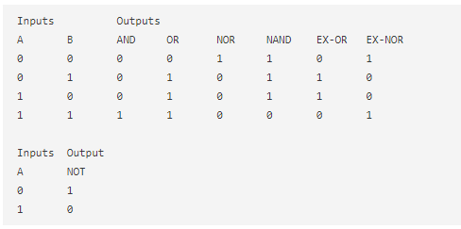

# PLC Program to Perform Various Boolean Functions



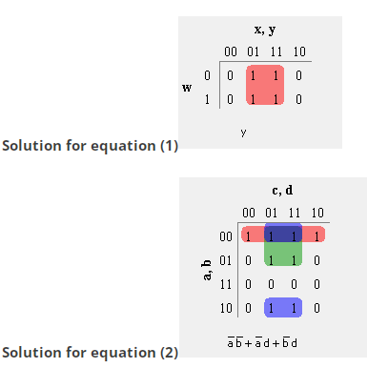

**PLC Program to Implement a Combinational Logic Circuit – Example 1**

**Problem Description**

The input to combinations logic circuit is a 4-bit binary number. Design the logic circuit with two outputs (Y1, Y2) for the following conditions. Also develop PLC program in Ladder Logic for the same.

Y1=1 if the input binary number is 5 or less than 5.

Y2=1 if the input binary number is 9 or more than 9.

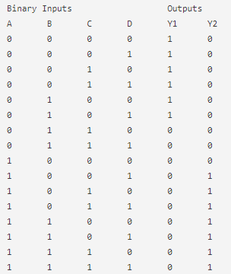

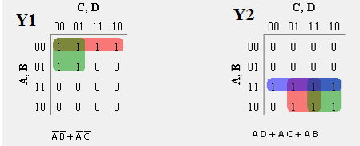

**Problem Description**

A circuit has 4 inputs (A, B, C, and D) and 2 outputs (Y1, Y2). One of the outputs is high when majority of inputs are high. The second output is high when all inputs are of same type. Design the combinational circuit and implement it in PLC using Ladder Diagram programming language.

Y1=1 if majority of inputs are high.

Y2=1 if A=B=C=D.

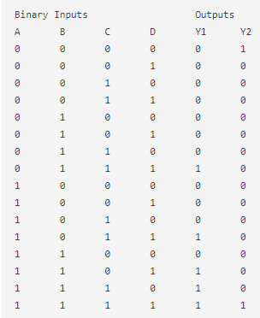

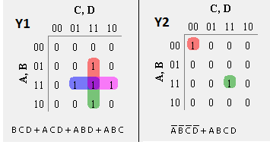

**PLC Program to Perform Various Boolean Functions with Don’t Care Condition**

F(A,B,C,D)=∑m(0,1,5,9,13,14,15) + d(3,4,7,10,11)

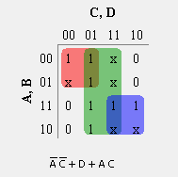

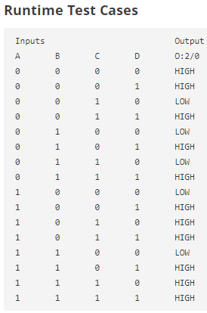

# Binary to BCD Conversion in PLC

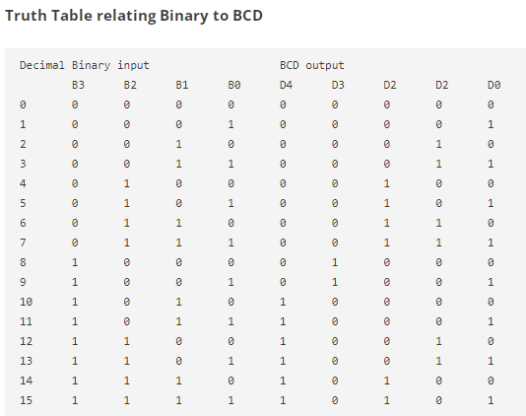

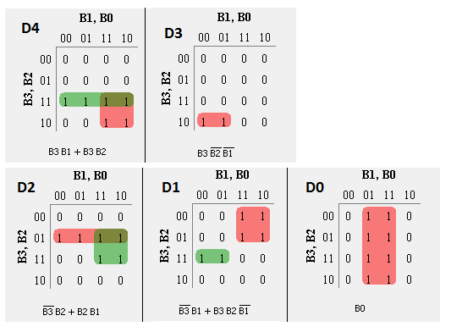

# PLC Program to Convert BCD to Excess-3

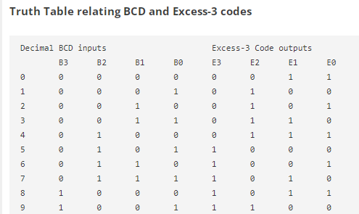

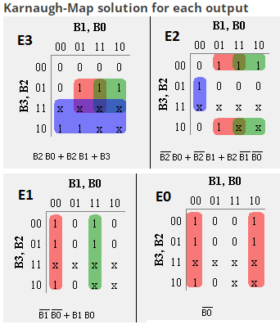

# Binary to Gray Code Conversion in PLC

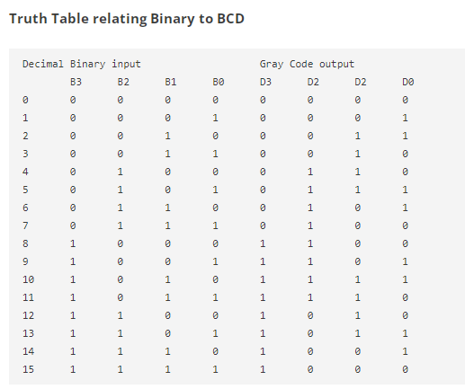

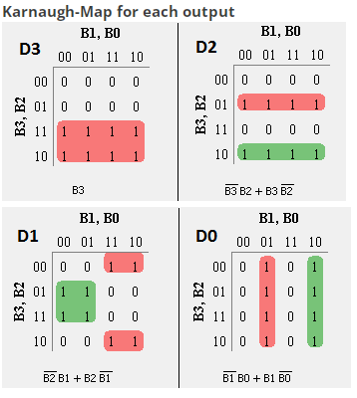

# PLC Program to Convert Gray Code to Binary

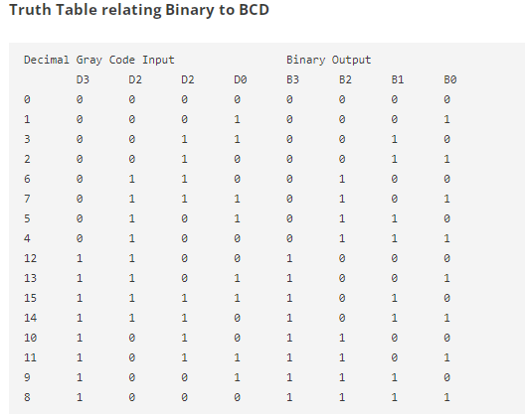

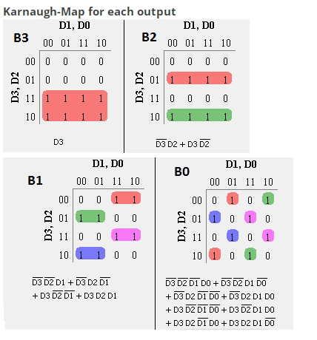

# PLC Program to Implement 2-bit Magnitude Comparator

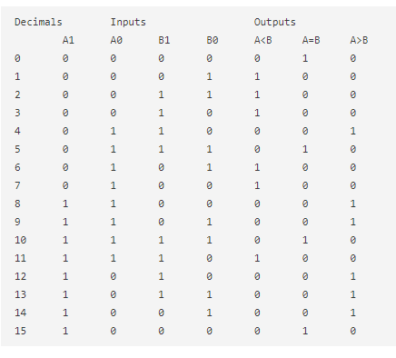

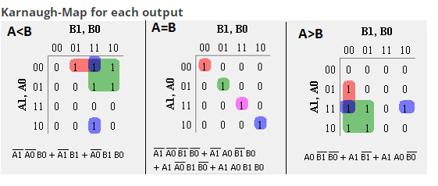

# PLC Program to Implement 4:1 Multiplexer

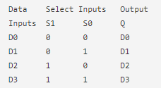

# PLC Program to Implement 8:1 Multiplexer

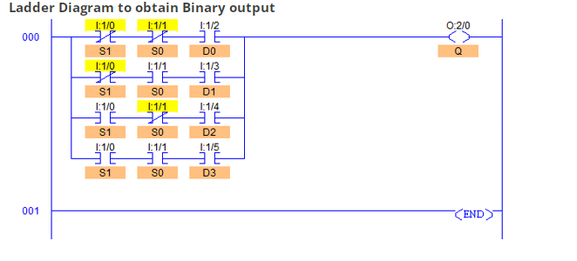

# PLC Program to Implement 8:1 Multiplexer

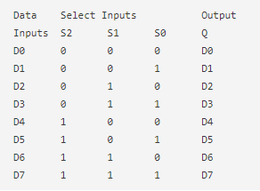

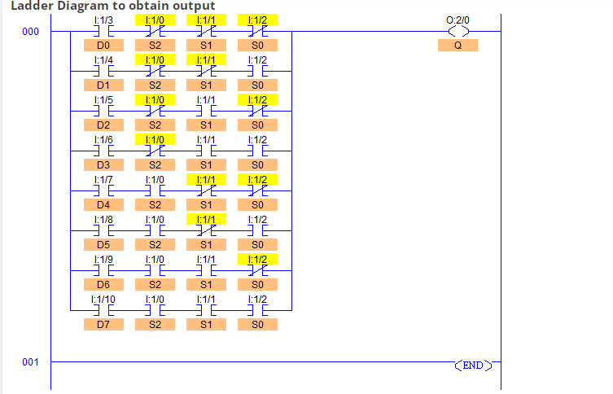

# PLC Program to Implement 1:8 Demultiplexer

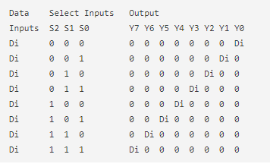

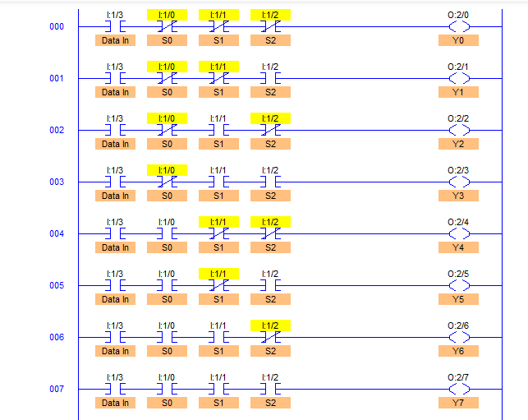

# PLC Program to Implement 3 to 8 Line Decoder

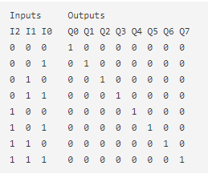

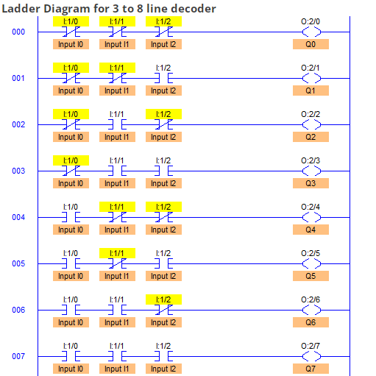

# PLC Program to Implement 8 to 3 Encoder

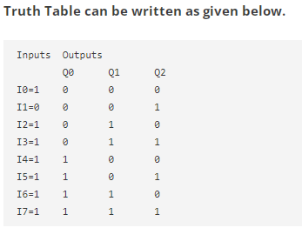

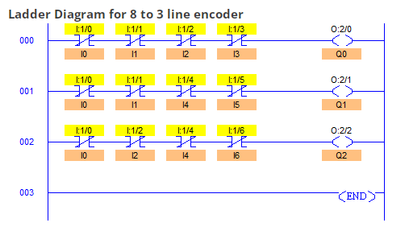

# PLC Program to Operate Seven Segment Display

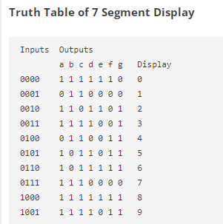

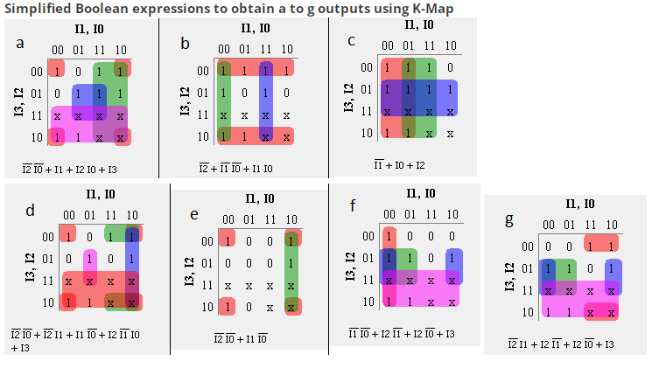

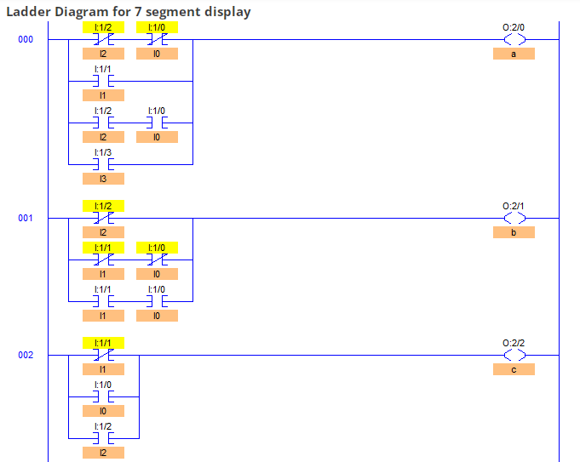

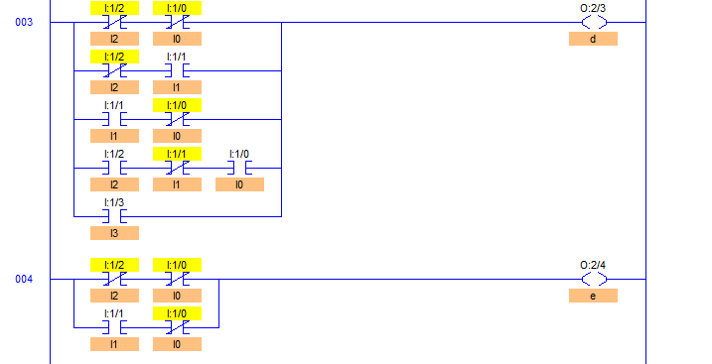

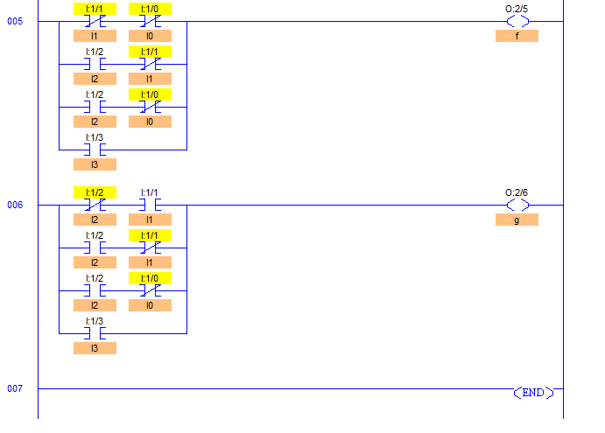

# PLC Program to Implement SR Flip-Flop

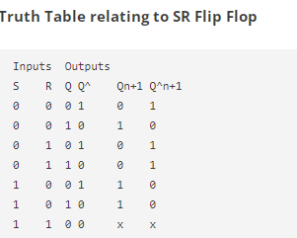

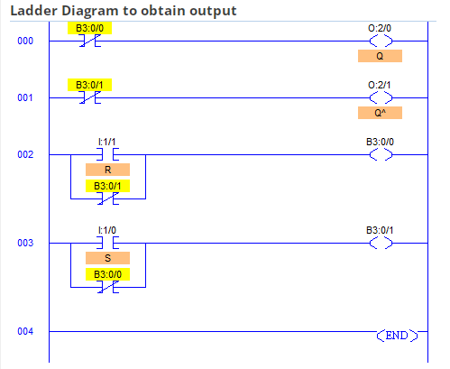

# PLC Program to Implement D Flip Flop

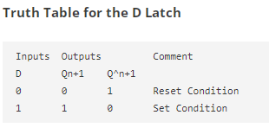

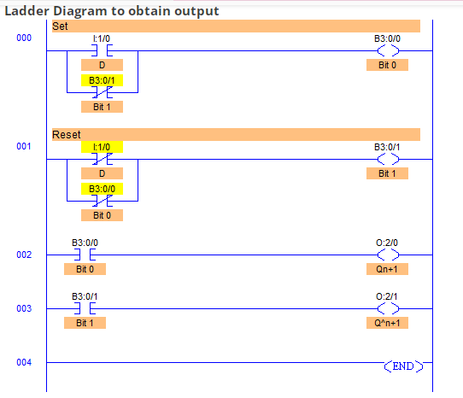

# PLC Program to Implement T Flip Flop



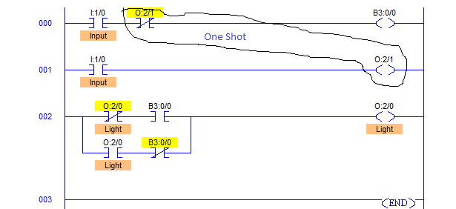

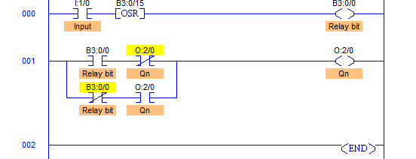

# PLC Program to Operate Stamping of Parts

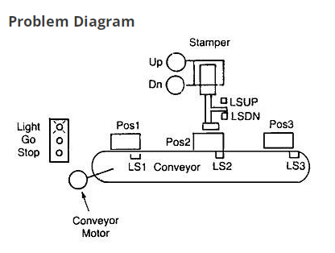

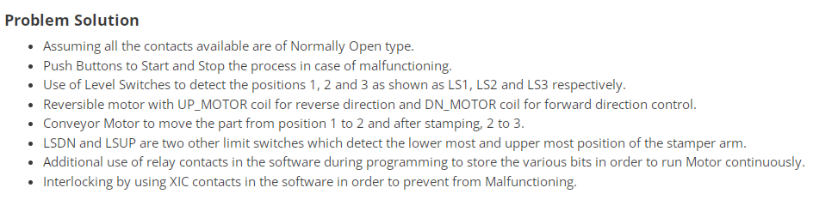

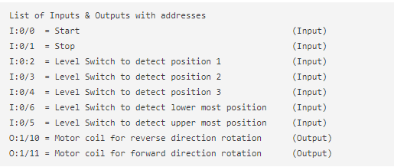

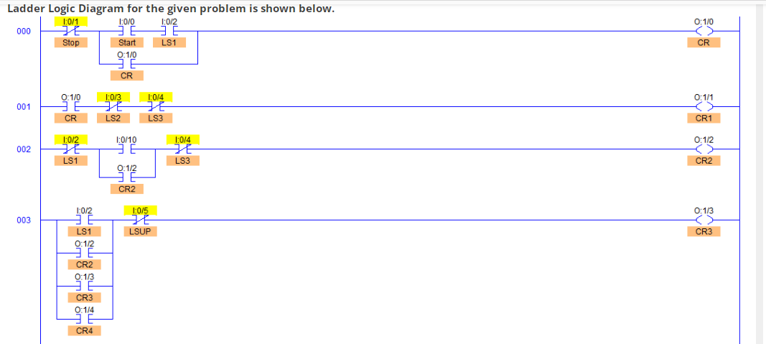

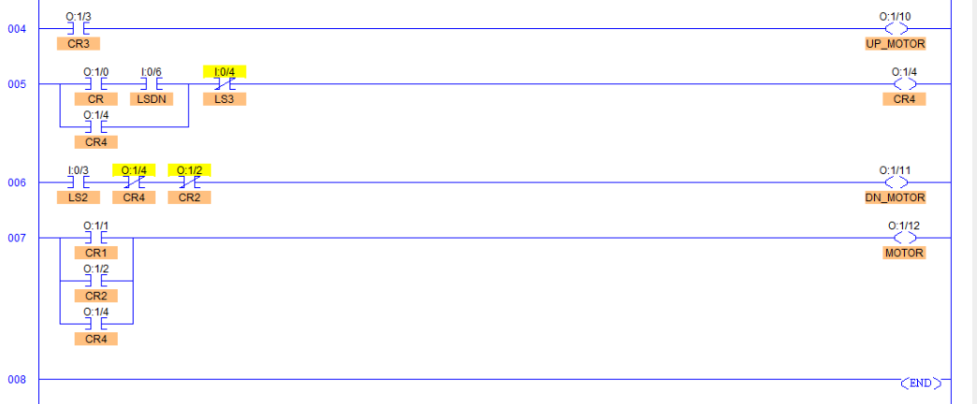



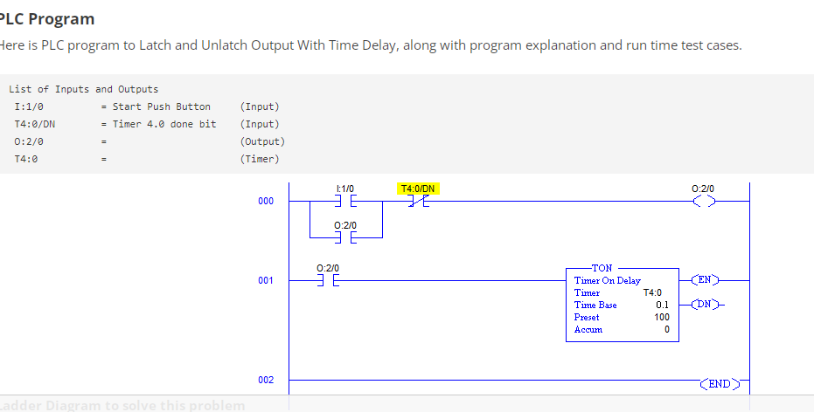

# PLC Program to Maintain the Capacity of a Particular Classroom

**Problem Description**

A classroom has a capacity of maximum 120 students. There are two doors, one for Entry and the other for Exit. When number of students in the classroom is less than 120, Entry door has a Green light on it which remains ON. When number of students in the classroom is 120 or more than that, Red light goes ON turning OFF the Green light which indicates that the classroom has reached its maximum capacity and is full.

**Problem Description**

* Considering the availability of two separate doors for Entry and Exit, two separate Proximity Switches can be used to detect entry and exit of students.
* One proximity switch is mounted at the Entry door and the other at the Exit door.
* Both the switches will generate two different outputs which can be then fed to PLC to operate the lights according to the Ladder Logic Program written in its memory.
* Counter must be used to count the number of students entering and exiting.
* Comparator must also be used to compare the count value with the given maximum capacity of 120.
* **PLC Program**
* Here is PLC program to Maintain the Capacity of a Particular Classroom, along with program explanation and run time test cases.
* List of Inputs and Outputs
* I:1/0 = Proximity Switch to detect Entry of a student. (Input)
* I:1/1 = Proximity Switch to detect Exit of a student. (Input)
* O:1/1 = Red Light to indicate availability in the classroom (Output)
* O:1/0 = Light to indicate classroom’s maximum capacity. (Output)
* C5:0 = Counter to count the number of students entering. (Counter)
* C5:0 = Counter to count the number of students exiting. (Counter)
* LES = Comparator to compare the counter value

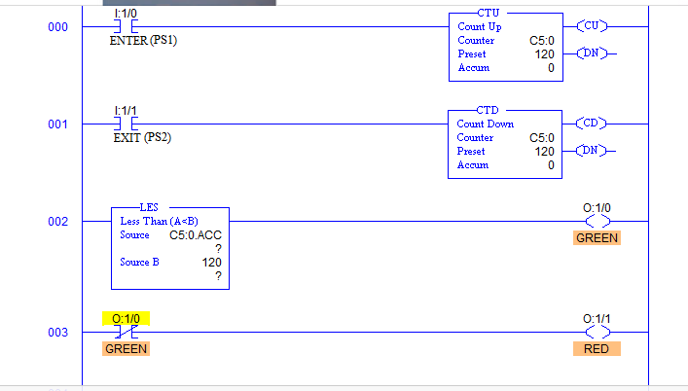

**PLC Program for Burglar Alarm Security System**

This is a PLC Program for Burglar Alarm Security System.

**Problem Description**

Consider the design of a Burglar Alarm for a house. This alarm will be activated if an unauthorized person is detected by a Window Sensor or a Motion Detector. Implement this Alarm System in PLC using Ladder Diagram programming language.

**Problem Solution**

* Basically two sensors are used, one is Motion Detector and other one Window Sensor.  
  Window sensor is nothing but a loop of wire that is a piece of thin metal foil which encircles the window.
* The motion detector is designed such that when a person is detected, the output of sensor goes true.
* Important thing to note here is that in Window Sensor, current is always passing until there is a breakage in glass of a window. Hence output is always true. When alarm system is active and someone tries to break the window, current does not flow through the metal foil causing output to go false.
* Karnaugh-Map can be used here to solve the equation and then to implement its logic in Ladder Diagram.

